**Assignment 3**

**Instruction: Please choose a visualization tool (no R) and recreate these visuals, no need to write conclusions this time. Please state which tool you use at the beginning of your document. For tools that don’t need to program, just submit visuals. Otherwise, submit your codes along with your visuals.**

You are a data scientist working for a consulting company. Netflix hired your company to help them identify some insights in movie industry. They will use the insights you discovered to make investment decisions in their newest movies. Now you are given this movie industry dataset, do some exploring and answer the questions from Netflix’s CEO. Since executives are highly visual, please explain using visualizations.

1. Does higher budget movie generate higher revenue (use adjusted gross revenue)? What’s the relationship between budget and adjusted gross revenues? Add a trend line to your visualization to tell a better story.
2. What genre makes highest revenue? Recommend top 5 best-selling genre by adjusted gross revenue.
3. Your teammate made this chart and your boss wants to present it to Netflix. But your teammate is on vacation and forgot to share his codes. Can you reproduce codes for this chart?

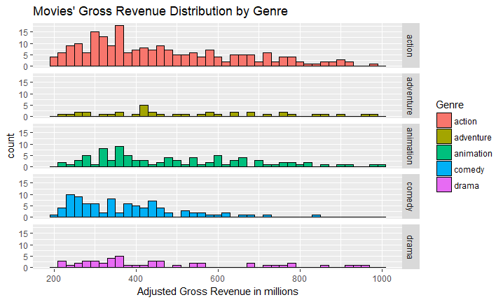

1. **Bonus 3 points: Create a visual showing how US revenue % changes over years by Genre**